**A Personal Finance Management App**

**1.INTRODUCTION**

**Overview**

One of the most valuable life skills is learning how to manage money, but it is important to start at the beginning. Why we use money in the first place and how to get the best value with our money should be explained. We should also explore our relationship with money.

Taking the time to understand the influence that money has in our lives can help to contribute to a healthy relationship with money. Students will learn through lessons and activities how money works and how they can make the most of it, thus ensuring they have better control of their money in the long run.

In this section, ‘Money Talks – what does it say about you?’, students will imagine a world without money, and will show why the concept of money evolved. They will complete barter activities and consider the fairness of the barter system.

In later lessons, they will look at how money influences many things they do. Students will then examine their own and other peoples’ attitude towards money.

This section is the first of four sections which all build on each other to help students gain/develop the skills and knowledge to make informed decisions about their personal finances for the stage when they begin earning and managing their own money.

**Purpose**

The purpose of implementing a money management program is to put you in complete control of your financial decisions, future savings goals and create a lifestyle by design.

Savings plan – setting a plan to suit your desired lifestyle but balance and align this with your longer term financial goals.

Bank structure and automation – Spending (Living and Lifestyle), Storage and Savings Accounts are a framework to build around your unique circumstances. Then pay yourself first and cap your discretionary spending. This way you get in the habit of only spending what’s left after you have allocated to your savings.

Feedback and accountability – A review of your accounts should provide the insight into how you are tracking towards your savings or debt repayment objectives.

Having a money management program isn’t about punishing yourself or a process of simply tracking your numbers. Building awareness through the implementation of a money management program will help with clarifying how your spending habits are impacting your long term financial objectives, and gives you the opportunity to make changes to suit your lifestyle.

**2.Problem Definition & Design Thinking**

**2.1 Empathy Map**

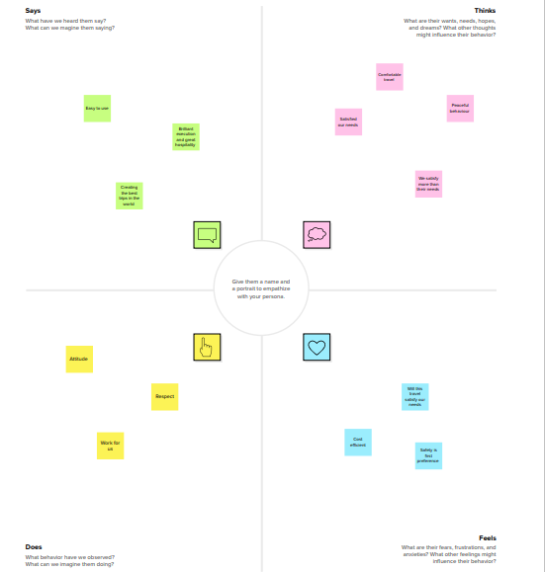

**2.2 Ideation and Brainstorming Map**

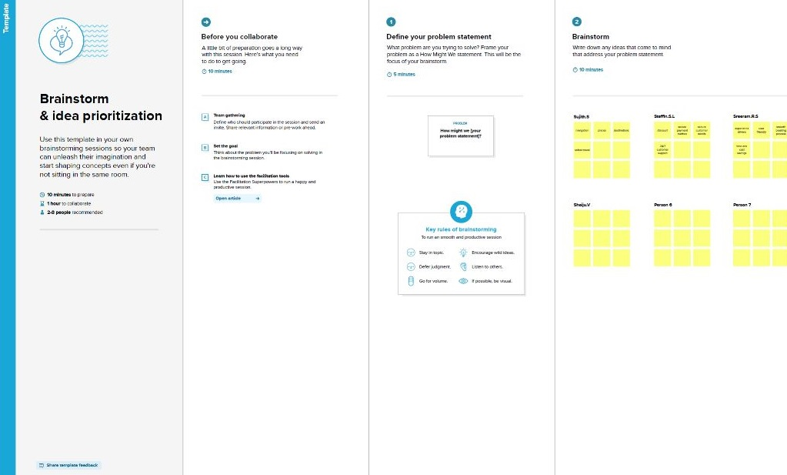

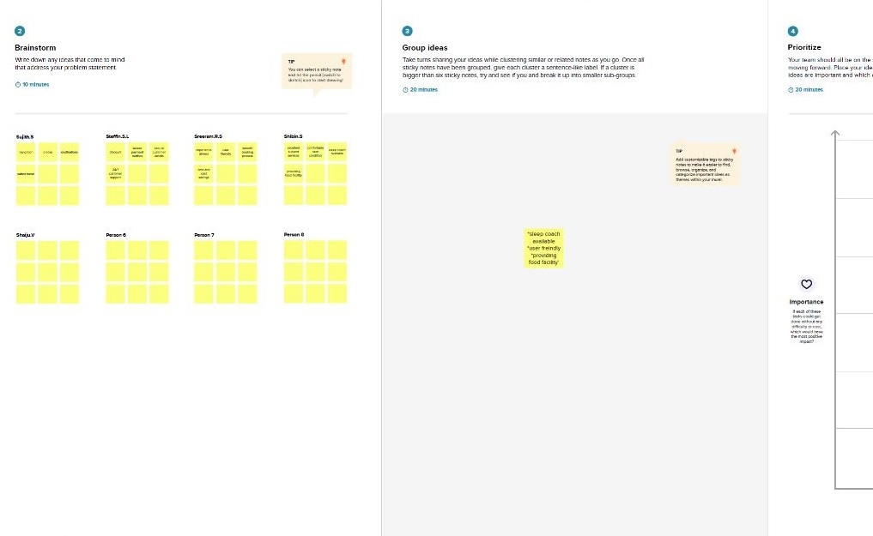

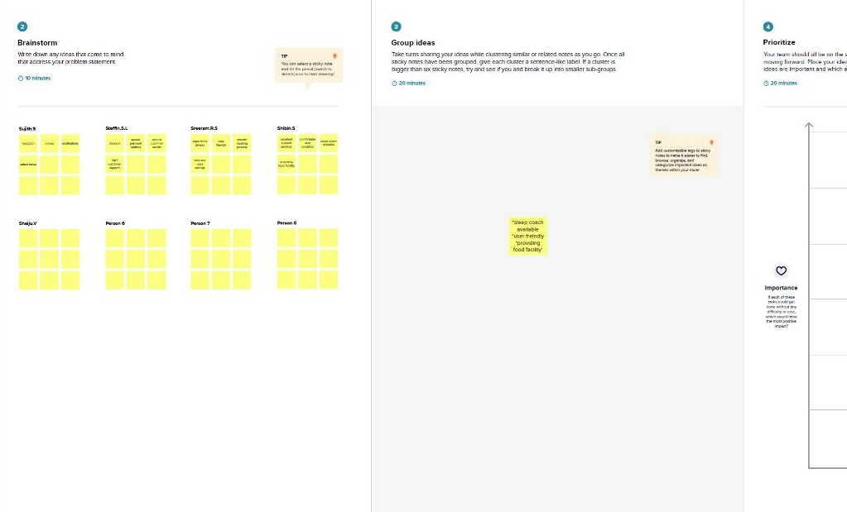

**RESULT**

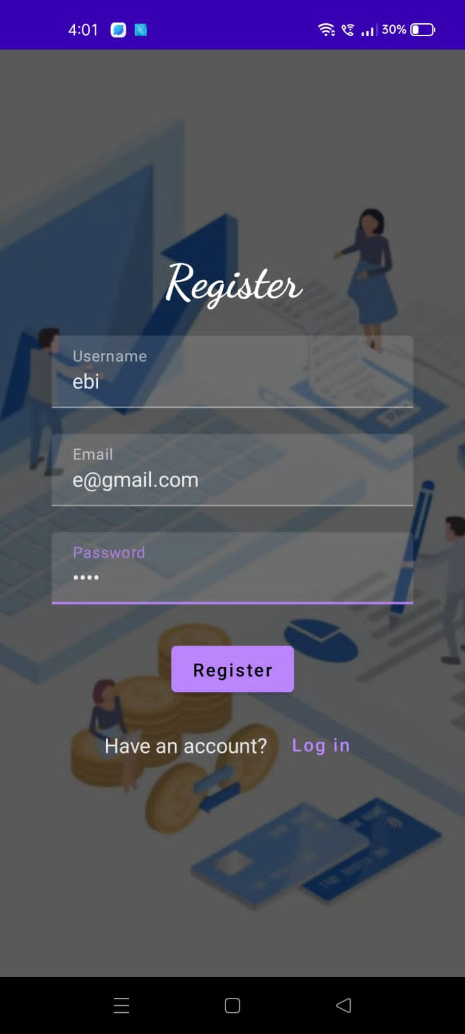

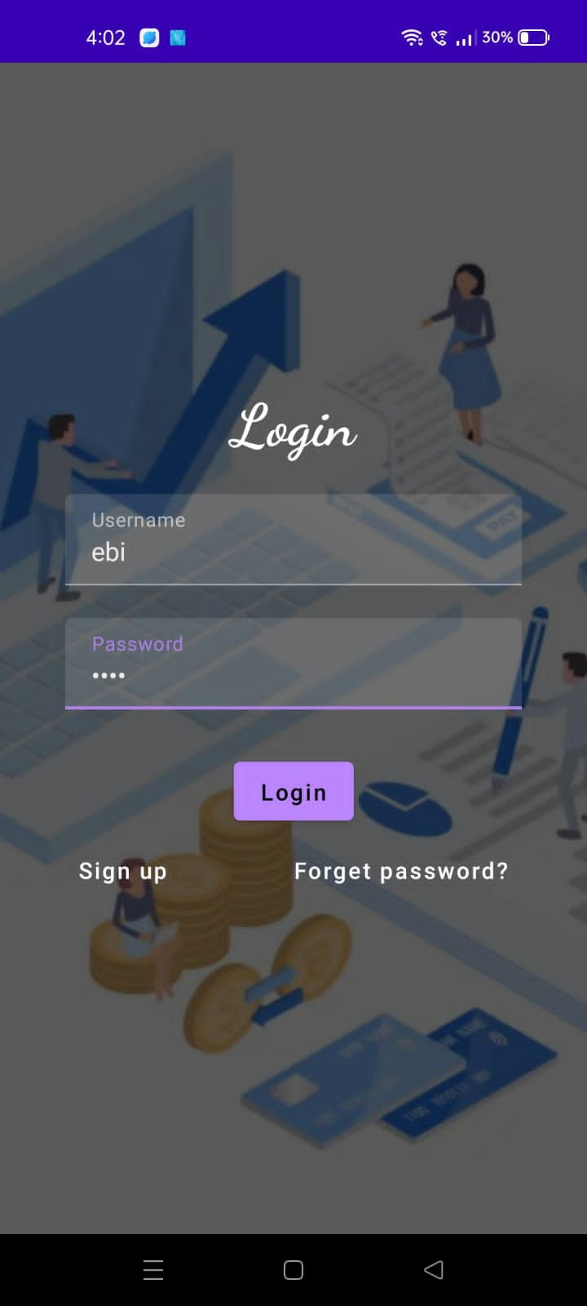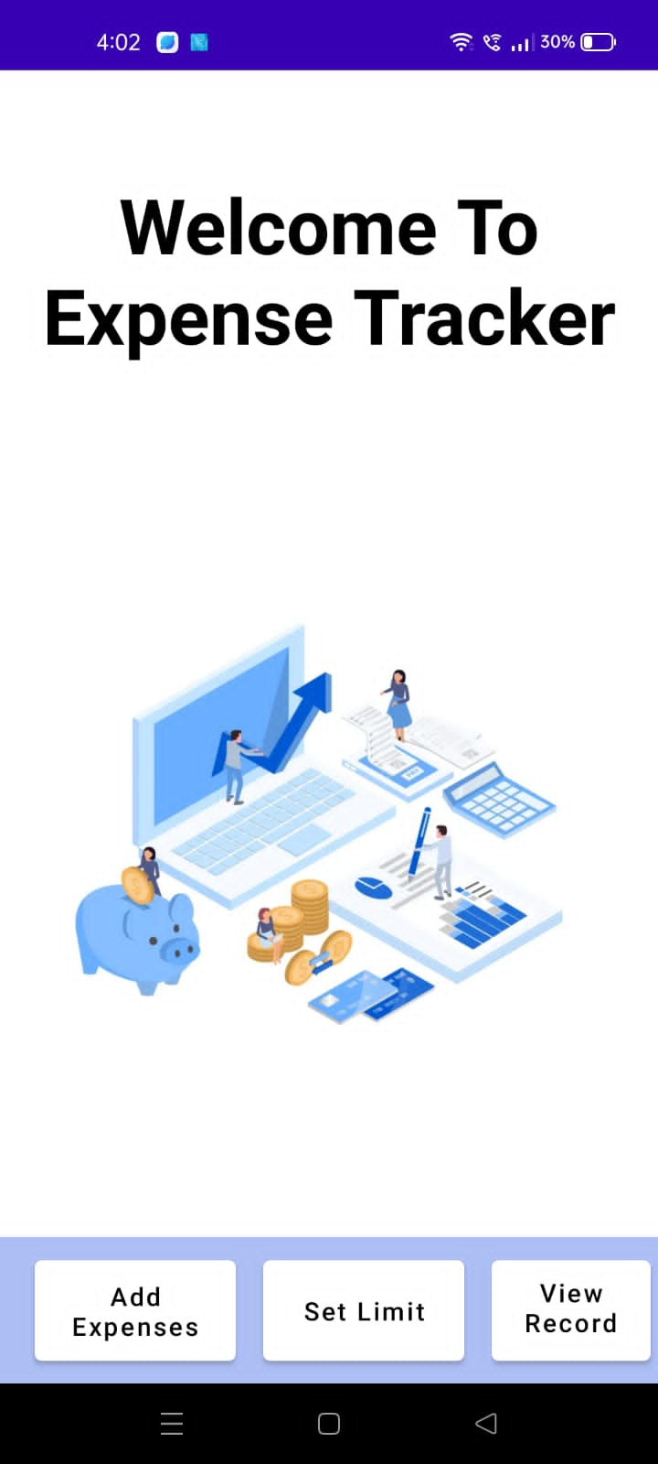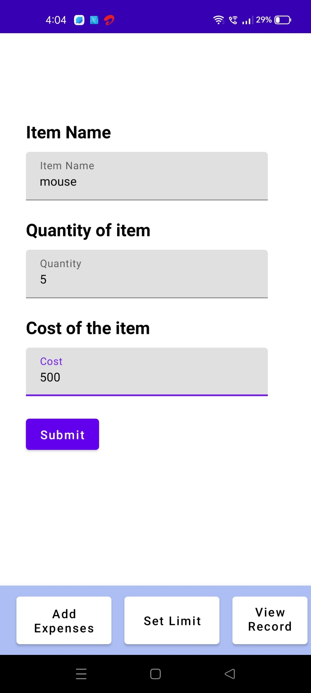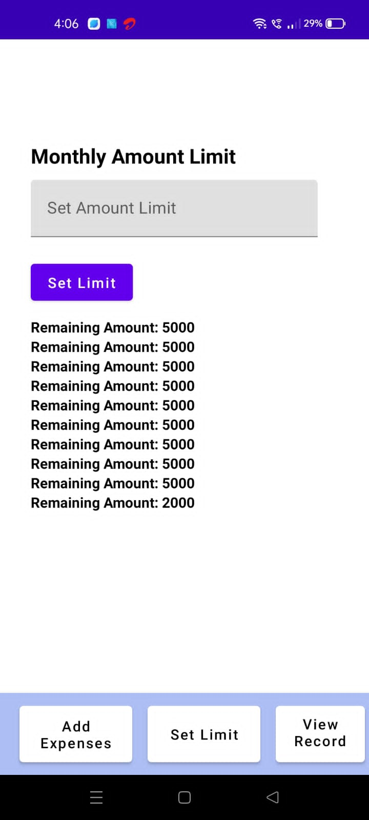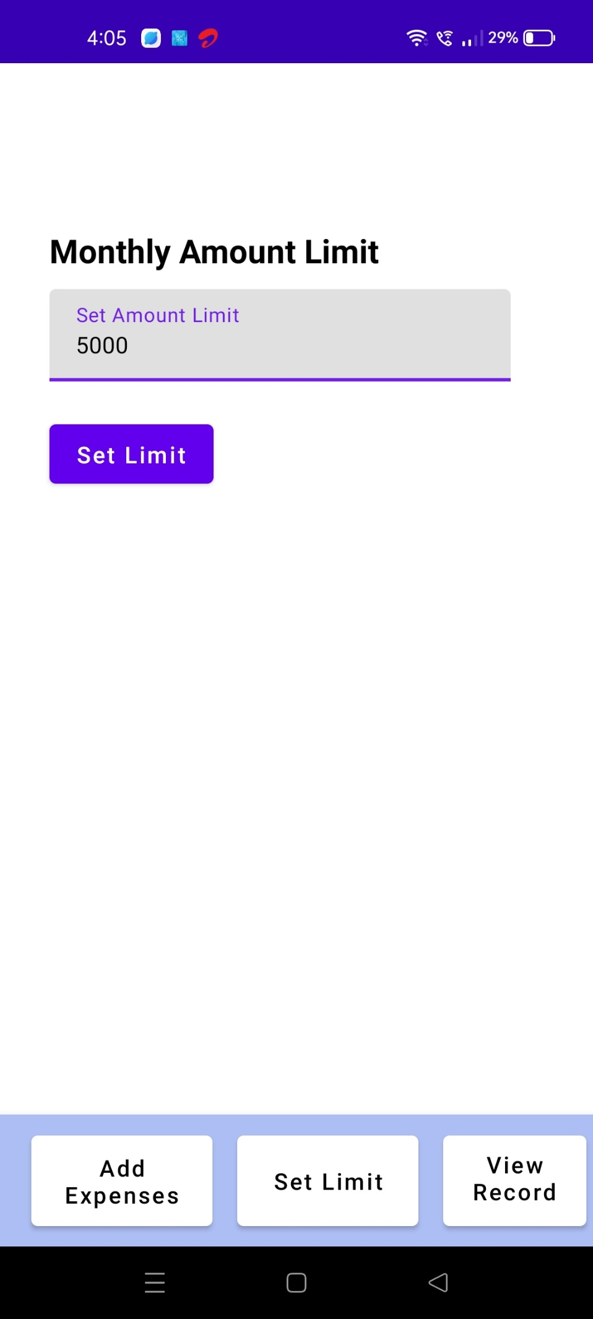

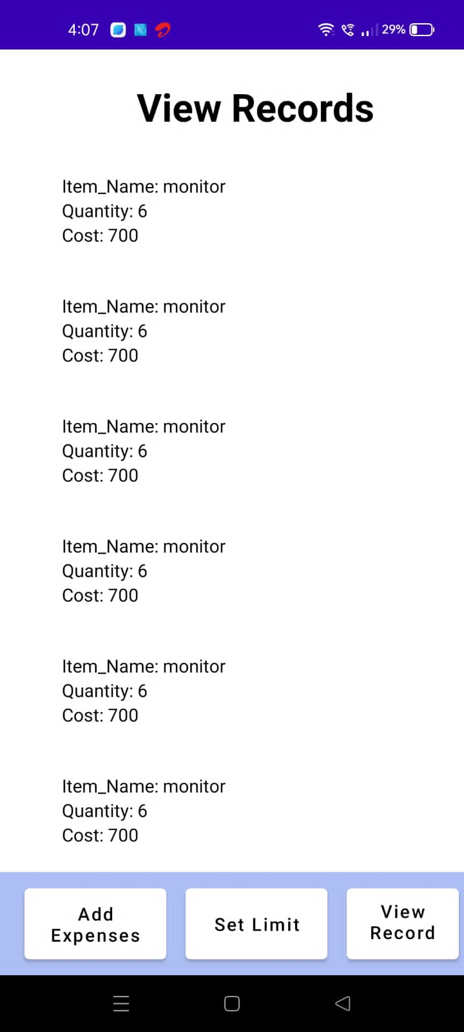

**ADVANTAGES & DISADVANTAGES**

**Advantages**

* More secure (as bank cards are not connected to these applications)
* Simple (and therefore, less expensive) personal finance app development cycle
* More command over the data (transactions)
* Ease of use - an application does not force the user to perform unnecessary actions
* High efficiency
* Automatic transaction updates

**Disadvantages**

* Human errors (among other things, a person may be too lazy to enter the data manually)
* Significant time costs
* No data synchronization
* When we are dealing with money, security becomes a primary concern
* The task to build a complex/linked personal finance app is relatively complicated and expensive

**APPLICATIONS**

* Customized Travel Planning: With a personalized travel planning app, users can create custom travel itineraries that cater to their preferences and interests. Users can input details about their budget, preferred activities, and travel dates, and the app will provide recommendations for accommodations, attractions, restaurants, and other activities that suit their interests.
* Real-time Tracking: Travelers can use the app to track their itinerary, monitor flight or train schedules, and receive real-time updates about changes or delays. This can help them stay on schedule and make necessary adjustments on the go.
* Location-based Recommendations: The app can use location data to provide personalized recommendations for nearby attractions, restaurants, and events. This feature can help travellers discover new places and experiences they may not have otherwise known about.
* Social Sharing: Users can share their travel plans, experiences, and recommendations with friends and family through social media or within the app. This can help build a community of travellers and provide useful insights and tips for others planning similar trips.

**CONCLUSION**

In conclusion, a Personalized Travel Planning and Tracking App developed in android studio can offer a wide range of benefits for both travellers and tourism industry professionals. With features such as customized travel planning, real-time tracking, location-based recommendations, social sharing, and analytics, the app can help users create personalized itineraries that cater to their interests and preferences, while also providing valuable insights for tourism industry professionals. As more people turn to technology for travel planning and organization, the development of such apps is likely to become increasingly important in the tourism industry.

**FUTURE SCOPE**

* Artificial Intelligence and Machine Learning: Integrating AI and machine learning capabilities into the app could allow it to learn from user behaviour and provide even more personalized recommendations and travel plans.
* Virtual Reality and Augmented Reality: Incorporating VR and AR technologies into the app could allow users to experience destinations and attractions virtually before they arrive, helping them make more informed travel decisions.
* Blockchain Technology: Implementing blockchain technology could help enhance the security and privacy of user data and transactions, which is especially important in the travel industry.
* Smart City Integration: Integrating with smart city technologies could allow the app to provide even more detailed and accurate recommendations based on real-time data about traffic, weather, and other factors.
* Sustainability and Responsible Tourism: As more travellers become conscious of the impact of their travel on the environment and local communities, the app could integrate features that promote sustainable and responsible tourism practices, such as eco-friendly accommodations and tours.

Overall, the future scope of a Personalized Travel Planning and Tracking App developed in android studio is vast, and there are many opportunities to continue enhancing and improving the app to meet the evolving needs of travellers and the tourism industry.



AndroidManifest.xml

<?xml version="1.0" encoding="utf-8"?>

<manifest xmlns:android="http://schemas.android.com/apk/res/android"

xmlns:tools="http://schemas.android.com/tools">

<application

android:allowBackup="true"

android:dataExtractionRules="@xml/data_extraction_rules"

android:fullBackupContent="@xml/backup_rules"

android:icon="@mipmap/ic_launcher"

android:label="@string/app_name"

android:supportsRtl="true"

android:theme="@style/Theme.ExpensesTracker"

tools:targetApi="31">

<activity

android:name=".RegisterActivity"

android:exported="false"

android:label="@string/title_activity_register"

android:theme="@style/Theme.ExpensesTracker" />

<activity

android:name=".MainActivity"

android:exported="false"

android:label="MainActivity"

android:theme="@style/Theme.ExpensesTracker" />

<activity

android:name=".ViewRecordsActivity"

android:exported="false"

android:label="@string/title_activity_view_records"

android:theme="@style/Theme.ExpensesTracker" />

<activity

android:name=".SetLimitActivity"

android:exported="false"

android:label="@string/title_activity_set_limit"

android:theme="@style/Theme.ExpensesTracker" />

<activity

android:name=".AddExpensesActivity"

android:exported="false"

android:label="@string/title_activity_add_expenses"

android:theme="@style/Theme.ExpensesTracker" />

<activity

android:name=".LoginActivity"

android:exported="true"

android:label="@string/app_name"

android:theme="@style/Theme.ExpensesTracker">

<intent-filter>

<action android:name="android.intent.action.MAIN" />

<category android:name="android.intent.category.LAUNCHER" />

</intent-filter>

</activity>

</application>

</manifest>

AddExpensesActivity.kt

package com.example.expensestracker

import android.annotation.SuppressLint

import android.content.Context

import android.content.Intent

import android.os.Bundle

import android.widget.Toast

import androidx.activity.ComponentActivity

import androidx.activity.compose.setContent

import androidx.compose.foundation.layout.*

import androidx.compose.material.*

import androidx.compose.runtime.*

import androidx.compose.ui.Alignment

import androidx.compose.ui.Modifier

import androidx.compose.ui.graphics.Color

import androidx.compose.ui.platform.LocalContext

import androidx.compose.ui.text.font.FontWeight

import androidx.compose.ui.text.style.TextAlign

import androidx.compose.ui.unit.dp

import androidx.compose.ui.unit.sp

class AddExpensesActivity : ComponentActivity() {

private lateinit var itemsDatabaseHelper: ItemsDatabaseHelper

private lateinit var expenseDatabaseHelper: ExpenseDatabaseHelper

@SuppressLint("UnusedMaterialScaffoldPaddingParameter")

override fun onCreate(savedInstanceState: Bundle?) {

super.onCreate(savedInstanceState)

itemsDatabaseHelper = ItemsDatabaseHelper(this)

expenseDatabaseHelper = ExpenseDatabaseHelper(this)

setContent {

Scaffold(

// in scaffold we are specifying top bar.

bottomBar = {

// inside top bar we are specifying

// background color.

BottomAppBar(backgroundColor = Color(0xFFadbef4),

modifier = Modifier.height(80.dp),

// along with that we are specifying

// title for our top bar.

content = {

Spacer(modifier = Modifier.width(15.dp))

Button(

onClick = {startActivity(Intent(applicationContext,AddExpensesActivity::class.java))},

colors = ButtonDefaults.buttonColors(backgroundColor = Color.White),

modifier = Modifier.size(height = 55.dp, width = 110.dp)

)

{

Text(

text = "Add Expenses", color = Color.Black, fontSize = 14.sp,

textAlign = TextAlign.Center

)

}

Spacer(modifier = Modifier.width(15.dp))

Button(

onClick = {

startActivity(

Intent(

applicationContext,

SetLimitActivity::class.java

)

)

},

colors = ButtonDefaults.buttonColors(backgroundColor = Color.White),

modifier = Modifier.size(height = 55.dp, width = 110.dp)

)

{

Text(

text = "Set Limit", color = Color.Black, fontSize = 14.sp,

textAlign = TextAlign.Center

)

}

Spacer(modifier = Modifier.width(15.dp))

Button(

onClick = {

startActivity(

Intent(

applicationContext,

ViewRecordsActivity::class.java

)

)

},

colors = ButtonDefaults.buttonColors(backgroundColor = Color.White),

modifier = Modifier.size(height = 55.dp, width = 110.dp)

)

{

Text(

text = "View Records", color = Color.Black, fontSize = 14.sp,

textAlign = TextAlign.Center

)

}

}

)

}

) {

AddExpenses(this, itemsDatabaseHelper, expenseDatabaseHelper)

}

}

}

}

@SuppressLint("Range")

@Composable

fun AddExpenses(context: Context, itemsDatabaseHelper: ItemsDatabaseHelper, expenseDatabaseHelper: ExpenseDatabaseHelper) {

Column(

modifier = Modifier

.padding(top = 100.dp, start = 30.dp)

.fillMaxHeight()

.fillMaxWidth(),

horizontalAlignment = Alignment.Start

) {

val mContext = LocalContext.current

var items by remember { mutableStateOf("") }

var quantity by remember { mutableStateOf("") }

var cost by remember { mutableStateOf("") }

var error by remember { mutableStateOf("") }

Text(text = "Item Name", fontWeight = FontWeight.Bold, fontSize = 20.sp)

Spacer(modifier = Modifier.height(10.dp))

TextField(value = items, onValueChange = { items = it },

label = { Text(text = "Item Name") })

Spacer(modifier = Modifier.height(20.dp))

Text(text = "Quantity of item", fontWeight = FontWeight.Bold, fontSize = 20.sp)

Spacer(modifier = Modifier.height(10.dp))

TextField(value = quantity, onValueChange = { quantity = it },

label = { Text(text = "Quantity") })

Spacer(modifier = Modifier.height(20.dp))

Text(text = "Cost of the item", fontWeight = FontWeight.Bold, fontSize = 20.sp)

Spacer(modifier = Modifier.height(10.dp))

TextField(value = cost, onValueChange = { cost = it },

label = { Text(text = "Cost") })

Spacer(modifier = Modifier.height(20.dp))

if (error.isNotEmpty()) {

Text(

text = error,

color = MaterialTheme.colors.error,

modifier = Modifier.padding(vertical = 16.dp)

)

}

Button(onClick = {

if (items.isNotEmpty() && quantity.isNotEmpty() && cost.isNotEmpty()) {

val items = Items(

id = null,

itemName = items,

quantity = quantity,

cost = cost

)

val limit= expenseDatabaseHelper.getExpenseAmount(1)

val actualvalue = limit?.minus(cost.toInt())

// Toast.makeText(mContext, actualvalue.toString(), Toast.LENGTH_SHORT).show()

val expense = Expense(

id = 1,

amount = actualvalue.toString()

)

if (actualvalue != null) {

if (actualvalue < 1) {

Toast.makeText(mContext, "Limit Over", Toast.LENGTH_SHORT).show()

} else {

expenseDatabaseHelper.updateExpense(expense)

itemsDatabaseHelper.insertItems(items)

}

}

}

}) {

Text(text = "Submit")

}

}

}

Expense.kt

package com.example.expensestracker

import androidx.room.ColumnInfo

import androidx.room.Entity

import androidx.room.PrimaryKey

@Entity(tableName = "expense_table")

data class Expense(

@PrimaryKey(autoGenerate = true) val id: Int?,

@ColumnInfo(name = "amount") val amount: String?,

)

ExpenseDao.kt

package com.example.expensestracker

import androidx.room.*

@Dao

interface ExpenseDao {

@Query("SELECT * FROM expense_table WHERE amount= :amount")

suspend fun getExpenseByAmount(amount: String): Expense?

@Insert(onConflict = OnConflictStrategy.REPLACE)

suspend fun insertExpense(items: Expense)

@Update

suspend fun updateExpense(items: Expense)

@Delete

suspend fun deleteExpense(items: Expense)

}

ExpenseDatabase.kt

package com.example.expensestracker

import android.content.Context

import androidx.room.Database

import androidx.room.Room

import androidx.room.RoomDatabase

@Database(entities = [Items::class], version = 1)

abstract class ExpenseDatabase : RoomDatabase() {

abstract fun ExpenseDao(): ItemsDao

companion object {

@Volatile

private var instance: ExpenseDatabase? = null

fun getDatabase(context: Context): ExpenseDatabase {

return instance ?: synchronized(this) {

val newInstance = Room.databaseBuilder(

context.applicationContext,

ExpenseDatabase::class.java,

"expense_database"

).build()

instance = newInstance

newInstance

}

}

}

}

ExpenseDatabaseHelper.kt

package com.example.expensestracker

import android.annotation.SuppressLint

import android.content.ContentValues

import android.content.Context

import android.database.Cursor

import android.database.sqlite.SQLiteDatabase

import android.database.sqlite.SQLiteOpenHelper

class ExpenseDatabaseHelper(context: Context) :

SQLiteOpenHelper(context, DATABASE_NAME, null,DATABASE_VERSION){

companion object {

private const val DATABASE_VERSION = 1

private const val DATABASE_NAME = "ExpenseDatabase.db"

private const val TABLE_NAME = "expense_table"

private const val COLUMN_ID = "id"

private const val COLUMN_AMOUNT = "amount"

}

override fun onCreate(db: SQLiteDatabase?) {

val createTable = "CREATE TABLE $TABLE_NAME (" +

"${COLUMN_ID} INTEGER PRIMARY KEY AUTOINCREMENT, " +

"${COLUMN_AMOUNT} TEXT" +

")"

db?.execSQL(createTable)

}

override fun onUpgrade(db1: SQLiteDatabase?, oldVersion: Int, newVersion: Int) {

db1?.execSQL("DROP TABLE IF EXISTS $TABLE_NAME")

onCreate(db1)

}

fun insertExpense(expense: Expense) {

val db1 = writableDatabase

val values = ContentValues()

values.put(COLUMN_AMOUNT, expense.amount)

db1.insert(TABLE_NAME, null, values)

db1.close()

}

fun updateExpense(expense: Expense) {

val db = writableDatabase

val values = ContentValues()

values.put(COLUMN_AMOUNT, expense.amount)

db.update(TABLE_NAME, values, "$COLUMN_ID=?", arrayOf(expense.id.toString()))

db.close()

}

@SuppressLint("Range")

fun getExpenseByAmount(amount: String): Expense? {

val db1 = readableDatabase

val cursor: Cursor = db1.rawQuery("SELECT * FROM ${ExpenseDatabaseHelper.TABLE_NAME} WHERE ${ExpenseDatabaseHelper.COLUMN_AMOUNT} = ?", arrayOf(amount))

var expense: Expense? = null

if (cursor.moveToFirst()) {

expense = Expense(

id = cursor.getInt(cursor.getColumnIndex(COLUMN_ID)),

amount = cursor.getString(cursor.getColumnIndex(COLUMN_AMOUNT)),

)

}

cursor.close()

db1.close()

return expense

}

@SuppressLint("Range")

fun getExpenseById(id: Int): Expense? {

val db1 = readableDatabase

val cursor: Cursor = db1.rawQuery("SELECT * FROM $TABLE_NAME WHERE $COLUMN_ID = ?", arrayOf(id.toString()))

var expense: Expense? = null

if (cursor.moveToFirst()) {

expense = Expense(

id = cursor.getInt(cursor.getColumnIndex(COLUMN_ID)),

amount = cursor.getString(cursor.getColumnIndex(COLUMN_AMOUNT)),

)

}

cursor.close()

db1.close()

return expense

}

@SuppressLint("Range")

fun getExpenseAmount(id: Int): Int? {

val db = readableDatabase

val query = "SELECT $COLUMN_AMOUNT FROM $TABLE_NAME WHERE $COLUMN_ID=?"

val cursor = db.rawQuery(query, arrayOf(id.toString()))

var amount: Int? = null

if (cursor.moveToFirst()) {

amount = cursor.getInt(cursor.getColumnIndex(COLUMN_AMOUNT))

}

cursor.close()

db.close()

return amount

}

@SuppressLint("Range")

fun getAllExpense(): List<Expense> {

val expenses = mutableListOf<Expense>()

val db1 = readableDatabase

val cursor: Cursor = db1.rawQuery("SELECT * FROM $TABLE_NAME", null)

if (cursor.moveToFirst()) {

do {

val expense = Expense(

id = cursor.getInt(cursor.getColumnIndex(COLUMN_ID)),

amount = cursor.getString(cursor.getColumnIndex(COLUMN_AMOUNT)),

)

expenses.add(expense)

} while (cursor.moveToNext())

}

cursor.close()

db1.close()

return expenses

}

}

Items.kt

package com.example.expensestracker

import androidx.room.ColumnInfo

import androidx.room.Entity

import androidx.room.PrimaryKey

@Entity(tableName = "items_table")

data class Items(

@PrimaryKey(autoGenerate = true) val id: Int?,

@ColumnInfo(name = "item_name") val itemName: String?,

@ColumnInfo(name = "quantity") val quantity: String?,

@ColumnInfo(name = "cost") val cost: String?,

)

ItemsDao.kt

package com.example.expensestracker

import androidx.room.*

@Dao

interface ItemsDao {

@Query("SELECT * FROM items_table WHERE cost= :cost")

suspend fun getItemsByCost(cost: String): Items?

@Insert(onConflict = OnConflictStrategy.REPLACE)

suspend fun insertItems(items: Items)

@Update

suspend fun updateItems(items: Items)

@Delete

suspend fun deleteItems(items: Items)

}

ItemsDatabase.kt

package com.example.expensestracker

import android.content.Context

import androidx.room.Database

import androidx.room.Room

import androidx.room.RoomDatabase

@Database(entities = [Items::class], version = 1)

abstract class ItemsDatabase : RoomDatabase() {

abstract fun ItemsDao(): ItemsDao

companion object {

@Volatile

private var instance: ItemsDatabase? = null

fun getDatabase(context: Context): ItemsDatabase {

return instance ?: synchronized(this) {

val newInstance = Room.databaseBuilder(

context.applicationContext,

ItemsDatabase::class.java,

"items_database"

).build()

instance = newInstance

newInstance

}

}

}

}

ItemsDatabaseHelper.kt

package com.example.expensestracker

import android.annotation.SuppressLint

import android.content.ContentValues

import android.content.Context

import android.database.Cursor

import android.database.sqlite.SQLiteDatabase

import android.database.sqlite.SQLiteOpenHelper

class ItemsDatabaseHelper(context: Context) :

SQLiteOpenHelper(context, DATABASE_NAME, null,DATABASE_VERSION){

companion object {

private const val DATABASE_VERSION = 1

private const val DATABASE_NAME = "ItemsDatabase.db"

private const val TABLE_NAME = "items_table"

private const val COLUMN_ID = "id"

private const val COLUMN_ITEM_NAME = "item_name"

private const val COLUMN_QUANTITY = "quantity"

private const val COLUMN_COST = "cost"

}

override fun onCreate(db: SQLiteDatabase?) {

val createTable = "CREATE TABLE $TABLE_NAME (" +

"${COLUMN_ID} INTEGER PRIMARY KEY AUTOINCREMENT, " +

"${COLUMN_ITEM_NAME} TEXT," +

"${COLUMN_QUANTITY} TEXT," +

"${COLUMN_COST} TEXT" +

")"

db?.execSQL(createTable)

}

override fun onUpgrade(db: SQLiteDatabase?, oldVersion: Int, newVersion: Int) {

db?.execSQL("DROP TABLE IF EXISTS $TABLE_NAME")

onCreate(db)

}

fun insertItems(items: Items) {

val db = writableDatabase

val values = ContentValues()

values.put(COLUMN_ITEM_NAME, items.itemName)

values.put(COLUMN_QUANTITY, items.quantity)

values.put(COLUMN_COST, items.cost)

db.insert(TABLE_NAME, null, values)

db.close()

}

@SuppressLint("Range")

fun getItemsByCost(cost: String): Items? {

val db = readableDatabase

val cursor: Cursor = db.rawQuery("SELECT * FROM $TABLE_NAME WHERE $COLUMN_COST = ?", arrayOf(cost))

var items: Items? = null

if (cursor.moveToFirst()) {

items = Items(

id = cursor.getInt(cursor.getColumnIndex(COLUMN_ID)),

itemName = cursor.getString(cursor.getColumnIndex(COLUMN_ITEM_NAME)),

quantity = cursor.getString(cursor.getColumnIndex(COLUMN_QUANTITY)),

cost = cursor.getString(cursor.getColumnIndex(COLUMN_COST)),

)

}

cursor.close()

db.close()

return items

}

@SuppressLint("Range")

fun getItemsById(id: Int): Items? {

val db = readableDatabase

val cursor: Cursor = db.rawQuery("SELECT * FROM $TABLE_NAME WHERE $COLUMN_ID = ?", arrayOf(id.toString()))

var items: Items? = null

if (cursor.moveToFirst()) {

items = Items(

id = cursor.getInt(cursor.getColumnIndex(COLUMN_ID)),

itemName = cursor.getString(cursor.getColumnIndex(COLUMN_ITEM_NAME)),

quantity = cursor.getString(cursor.getColumnIndex(COLUMN_QUANTITY)),

cost = cursor.getString(cursor.getColumnIndex(COLUMN_COST)),

)

}

cursor.close()

db.close()

return items

}

@SuppressLint("Range")

fun getAllItems(): List<Items> {

val item = mutableListOf<Items>()

val db = readableDatabase

val cursor: Cursor = db.rawQuery("SELECT * FROM $TABLE_NAME", null)

if (cursor.moveToFirst()) {

do {

val items = Items(

id = cursor.getInt(cursor.getColumnIndex(COLUMN_ID)),

itemName = cursor.getString(cursor.getColumnIndex(COLUMN_ITEM_NAME)),

quantity = cursor.getString(cursor.getColumnIndex(COLUMN_QUANTITY)),

cost = cursor.getString(cursor.getColumnIndex(COLUMN_COST)),

)

item.add(items)

} while (cursor.moveToNext())

}

cursor.close()

db.close()

return item

}

}

LoginActivity.kt

package com.example.expensestracker

import android.content.Context

import android.content.Intent

import android.os.Bundle

import androidx.activity.ComponentActivity

import androidx.activity.compose.setContent

import androidx.compose.foundation.Image

import androidx.compose.foundation.layout.*

import androidx.compose.material.*

import androidx.compose.runtime.*

import androidx.compose.ui.Alignment

import androidx.compose.ui.Modifier

import androidx.compose.ui.graphics.Color

import androidx.compose.ui.layout.ContentScale

import androidx.compose.ui.res.painterResource

import androidx.compose.ui.text.font.FontFamily

import androidx.compose.ui.text.font.FontWeight

import androidx.compose.ui.text.input.PasswordVisualTransformation

import androidx.compose.ui.text.input.VisualTransformation

import androidx.compose.ui.tooling.preview.Preview

import androidx.compose.ui.unit.dp

import androidx.compose.ui.unit.sp

import androidx.core.content.ContextCompat

import com.example.expensestracker.ui.theme.ExpensesTrackerTheme

class LoginActivity : ComponentActivity() {

private lateinit var databaseHelper: UserDatabaseHelper

override fun onCreate(savedInstanceState: Bundle?) {

super.onCreate(savedInstanceState)

databaseHelper = UserDatabaseHelper(this)

setContent {

ExpensesTrackerTheme {

// A surface container using the 'background' color from the theme

Surface(

modifier = Modifier.fillMaxSize(),

color = MaterialTheme.colors.background

) {

LoginScreen(this, databaseHelper)

}

}

}

}

}

@Composable

fun LoginScreen(context: Context, databaseHelper: UserDatabaseHelper) {

Image(

painterResource(id = R.drawable.img_1), contentDescription = "",

alpha =0.3F,

contentScale = ContentScale.FillHeight,

)

var username by remember { mutableStateOf("") }

var password by remember { mutableStateOf("") }

var error by remember { mutableStateOf("") }

Column(

modifier = Modifier.fillMaxSize(),

horizontalAlignment = Alignment.CenterHorizontally,

verticalArrangement = Arrangement.Center

) {

Text(

fontSize = 36.sp,

fontWeight = FontWeight.ExtraBold,

fontFamily = FontFamily.Cursive,

color = Color.White,

text = "Login"

)

Spacer(modifier = Modifier.height(10.dp))

TextField(

value = username,

onValueChange = { username = it },

label = { Text("Username") },

modifier = Modifier.padding(10.dp)

.width(280.dp)

)

TextField(

value = password,

onValueChange = { password = it },

label = { Text("Password") },

modifier = Modifier.padding(10.dp)

.width(280.dp),

visualTransformation = PasswordVisualTransformation()

)

if (error.isNotEmpty()) {

Text(

text = error,

color = MaterialTheme.colors.error,

modifier = Modifier.padding(vertical = 16.dp)

)

}

Button(

onClick = {

if (username.isNotEmpty() && password.isNotEmpty()) {

val user = databaseHelper.getUserByUsername(username)

if (user != null && user.password == password) {

error = "Successfully log in"

context.startActivity(

Intent(

context,

MainActivity::class.java

)

)

//onLoginSuccess()

}

else {

error = "Invalid username or password"

}

} else {

error = "Please fill all fields"

}

},

modifier = Modifier.padding(top = 16.dp)

) {

Text(text = "Login")

}

Row {

TextButton(onClick = {context.startActivity(

Intent(

context,

RegisterActivity::class.java

)

)}

)

{ Text(color = Color.White,text = "Sign up") }

TextButton(onClick = {

})

{

Spacer(modifier = Modifier.width(60.dp))

Text(color = Color.White,text = "Forget password?")

}

}

}

}

private fun startMainPage(context: Context) {

val intent = Intent(context, MainActivity::class.java)

ContextCompat.startActivity(context, intent, null)

}

MainActivity.kt

package com.example.expensestracker

import android.annotation.SuppressLint

import android.content.Intent

import android.os.Bundle

import androidx.activity.ComponentActivity

import androidx.activity.compose.setContent

import androidx.compose.foundation.Image

import androidx.compose.foundation.layout.*

import androidx.compose.material.*

import androidx.compose.runtime.*

import androidx.compose.ui.Alignment

import androidx.compose.ui.Modifier

import androidx.compose.ui.graphics.Color

import androidx.compose.ui.res.painterResource

import androidx.compose.ui.text.font.FontWeight

import androidx.compose.ui.text.style.TextAlign

import androidx.compose.ui.tooling.preview.Preview

import androidx.compose.ui.unit.dp

import androidx.compose.ui.unit.sp

import com.example.expensestracker.ui.theme.ExpensesTrackerTheme

class MainActivity : ComponentActivity() {

@SuppressLint("UnusedMaterialScaffoldPaddingParameter")

override fun onCreate(savedInstanceState: Bundle?) {

super.onCreate(savedInstanceState)

setContent {

Scaffold(

// in scaffold we are specifying top bar.

bottomBar = {

// inside top bar we are specifying

// background color.

BottomAppBar(backgroundColor = Color(0xFFadbef4),

modifier = Modifier.height(80.dp),

// along with that we are specifying

// title for our top bar.

content = {

Spacer(modifier = Modifier.width(15.dp))

Button(

onClick = {startActivity(Intent(applicationContext,AddExpensesActivity::class.java))},

colors = ButtonDefaults.buttonColors(backgroundColor = Color.White),

modifier = Modifier.size(height = 55.dp, width = 110.dp)

)

{

Text(

text = "Add Expenses", color = Color.Black, fontSize = 14.sp,

textAlign = TextAlign.Center

)

}

Spacer(modifier = Modifier.width(15.dp))

Button(

onClick = {

startActivity(

Intent(

applicationContext,

SetLimitActivity::class.java

)

)

},

colors = ButtonDefaults.buttonColors(backgroundColor = Color.White),

modifier = Modifier.size(height = 55.dp, width = 110.dp)

)

{

Text(

text = "Set Limit", color = Color.Black, fontSize = 14.sp,

textAlign = TextAlign.Center

)

}

Spacer(modifier = Modifier.width(15.dp))

Button(

onClick = {

startActivity(

Intent(

applicationContext,

ViewRecordsActivity::class.java

)

)

},

colors = ButtonDefaults.buttonColors(backgroundColor = Color.White),

modifier = Modifier.size(height = 55.dp, width = 110.dp)

)

{

Text(

text = "View Records", color = Color.Black, fontSize = 14.sp,

textAlign = TextAlign.Center

)

}

}

)

}

) {

MainPage()

}

}

}

}

@Composable

fun MainPage() {

Column(

modifier = Modifier.padding(20.dp).fillMaxSize(),

verticalArrangement = Arrangement.Center,

horizontalAlignment = Alignment.CenterHorizontally

) {

Text(text = "Welcome To Expense Tracker", fontSize = 42.sp, fontWeight = FontWeight.Bold,

textAlign = TextAlign.Center)

Image(painterResource(id = R.drawable.img_1), contentDescription ="", modifier = Modifier.size(height = 500.dp, width = 500.dp))

}

}

RegisterActivity.kt

package com.example.expensestracker

import android.content.Context

import android.content.Intent

import android.os.Bundle

import androidx.activity.ComponentActivity

import androidx.activity.compose.setContent

import androidx.compose.foundation.Image

import androidx.compose.foundation.layout.*

import androidx.compose.material.*

import androidx.compose.runtime.*

import androidx.compose.ui.Alignment

import androidx.compose.ui.Modifier

import androidx.compose.ui.graphics.Color

import androidx.compose.ui.layout.ContentScale

import androidx.compose.ui.res.painterResource

import androidx.compose.ui.text.font.FontFamily

import androidx.compose.ui.text.font.FontWeight

import androidx.compose.ui.text.input.PasswordVisualTransformation

import androidx.compose.ui.tooling.preview.Preview

import androidx.compose.ui.unit.dp

import androidx.compose.ui.unit.sp

import androidx.core.content.ContextCompat

import com.example.expensestracker.ui.theme.ExpensesTrackerTheme

class RegisterActivity : ComponentActivity() {

private lateinit var databaseHelper: UserDatabaseHelper

override fun onCreate(savedInstanceState: Bundle?) {

super.onCreate(savedInstanceState)

databaseHelper = UserDatabaseHelper(this)

setContent {

ExpensesTrackerTheme {

// A surface container using the 'background' color from the theme

Surface(

modifier = Modifier.fillMaxSize(),

color = MaterialTheme.colors.background

) {

RegistrationScreen(this,databaseHelper)

}

}

}

}

}

@Composable

fun RegistrationScreen(context: Context, databaseHelper: UserDatabaseHelper) {

Image(

painterResource(id = R.drawable.img_1), contentDescription = "",

alpha =0.3F,

contentScale = ContentScale.FillHeight,

)

var username by remember { mutableStateOf("") }

var password by remember { mutableStateOf("") }

var email by remember { mutableStateOf("") }

var error by remember { mutableStateOf("") }

Column(

modifier = Modifier.fillMaxSize(),

horizontalAlignment = Alignment.CenterHorizontally,

verticalArrangement = Arrangement.Center

) {

Text(

fontSize = 36.sp,

fontWeight = FontWeight.ExtraBold,

fontFamily = FontFamily.Cursive,

color = Color.White,

text = "Register"

)

Spacer(modifier = Modifier.height(10.dp))

TextField(

value = username,

onValueChange = { username = it },

label = { Text("Username") },

modifier = Modifier

.padding(10.dp)

.width(280.dp)

)

TextField(

value = email,

onValueChange = { email = it },

label = { Text("Email") },

modifier = Modifier

.padding(10.dp)

.width(280.dp)

)

TextField(

value = password,

onValueChange = { password = it },

label = { Text("Password") },

modifier = Modifier

.padding(10.dp)

.width(280.dp),

visualTransformation = PasswordVisualTransformation()

)

if (error.isNotEmpty()) {

Text(

text = error,

color = MaterialTheme.colors.error,

modifier = Modifier.padding(vertical = 16.dp)

)

}

Button(

onClick = {

if (username.isNotEmpty() && password.isNotEmpty() && email.isNotEmpty()) {

val user = User(

id = null,

firstName = username,

lastName = null,

email = email,

password = password

)

databaseHelper.insertUser(user)

error = "User registered successfully"

// Start LoginActivity using the current context

context.startActivity(

Intent(

context,

LoginActivity::class.java

)

)

} else {

error = "Please fill all fields"

}

},

modifier = Modifier.padding(top = 16.dp)

) {

Text(text = "Register")

}

Spacer(modifier = Modifier.width(10.dp))

Spacer(modifier = Modifier.height(10.dp))

Row() {

Text(

modifier = Modifier.padding(top = 14.dp), text = "Have an account?"

)

TextButton(onClick = {

context.startActivity(

Intent(

context,

LoginActivity::class.java

)

)

})

{

Spacer(modifier = Modifier.width(10.dp))

Text(text = "Log in")

}

}

}

}

private fun startLoginActivity(context: Context) {

val intent = Intent(context, LoginActivity::class.java)

ContextCompat.startActivity(context, intent, null)

}

SetLimitActivity.kt

package com.example.expensestracker

import android.annotation.SuppressLint

import android.content.Context

import android.content.Intent

import android.os.Bundle

import android.util.Log

import androidx.activity.ComponentActivity

import androidx.activity.compose.setContent

import androidx.compose.foundation.layout.*

import androidx.compose.foundation.lazy.LazyColumn

import androidx.compose.foundation.lazy.LazyRow

import androidx.compose.foundation.lazy.items

import androidx.compose.material.*

import androidx.compose.runtime.*

import androidx.compose.ui.Alignment

import androidx.compose.ui.Modifier

import androidx.compose.ui.graphics.Color

import androidx.compose.ui.text.font.FontWeight

import androidx.compose.ui.text.style.TextAlign

import androidx.compose.ui.unit.dp

import androidx.compose.ui.unit.sp

import com.example.expensestracker.ui.theme.ExpensesTrackerTheme

class SetLimitActivity : ComponentActivity() {

private lateinit var expenseDatabaseHelper: ExpenseDatabaseHelper

@SuppressLint("UnusedMaterialScaffoldPaddingParameter")

override fun onCreate(savedInstanceState: Bundle?) {

super.onCreate(savedInstanceState)

expenseDatabaseHelper = ExpenseDatabaseHelper(this)

setContent {

Scaffold(

// in scaffold we are specifying top bar.

bottomBar = {

// inside top bar we are specifying

// background color.

BottomAppBar(backgroundColor = Color(0xFFadbef4),

modifier = Modifier.height(80.dp),

// along with that we are specifying

// title for our top bar.

content = {

Spacer(modifier = Modifier.width(15.dp))

Button(

onClick = {

startActivity(

Intent(

applicationContext,

AddExpensesActivity::class.java

)

)

},

colors = ButtonDefaults.buttonColors(backgroundColor = Color.White),

modifier = Modifier.size(height = 55.dp, width = 110.dp)

)

{

Text(

text = "Add Expenses", color = Color.Black, fontSize = 14.sp,

textAlign = TextAlign.Center

)

}

Spacer(modifier = Modifier.width(15.dp))

Button(

onClick = {

startActivity(

Intent(

applicationContext,

SetLimitActivity::class.java

)

)

},

colors = ButtonDefaults.buttonColors(backgroundColor = Color.White),

modifier = Modifier.size(height = 55.dp, width = 110.dp)

)

{

Text(

text = "Set Limit", color = Color.Black, fontSize = 14.sp,

textAlign = TextAlign.Center

)

}

Spacer(modifier = Modifier.width(15.dp))

Button(

onClick = {

startActivity(

Intent(

applicationContext,

ViewRecordsActivity::class.java

)

)

},

colors = ButtonDefaults.buttonColors(backgroundColor = Color.White),

modifier = Modifier.size(height = 55.dp, width = 110.dp)

)

{

Text(

text = "View Records", color = Color.Black, fontSize = 14.sp,

textAlign = TextAlign.Center

)

}

}

)

}

) {

val data=expenseDatabaseHelper.getAllExpense();

Log.d("swathi" ,data.toString())

val expense = expenseDatabaseHelper.getAllExpense()

Limit(this, expenseDatabaseHelper,expense)

}

}

}

}

@Composable

fun Limit(context: Context, expenseDatabaseHelper: ExpenseDatabaseHelper, expense: List<Expense>) {

Column(

modifier = Modifier

.padding(top = 100.dp, start = 30.dp)

.fillMaxHeight()

.fillMaxWidth(),

horizontalAlignment = Alignment.Start

) {

var amount by remember { mutableStateOf("") }

var error by remember { mutableStateOf("") }

Text(text = "Monthly Amount Limit", fontWeight = FontWeight.Bold, fontSize = 20.sp)

Spacer(modifier = Modifier.height(10.dp))

TextField(value = amount, onValueChange = { amount = it },

label = { Text(text = "Set Amount Limit ") })

Spacer(modifier = Modifier.height(20.dp))

if (error.isNotEmpty()) {

Text(

text = error,

color = MaterialTheme.colors.error,

modifier = Modifier.padding(vertical = 16.dp)

)

}

Button(onClick = {

if (amount.isNotEmpty()) {

val expense = Expense(

id = null,

amount = amount

)

expenseDatabaseHelper.insertExpense(expense)

}

}) {

Text(text = "Set Limit")

}

Spacer(modifier = Modifier.height(10.dp))

LazyRow(

modifier = Modifier

.fillMaxSize()

.padding(top = 0.dp),

horizontalArrangement = Arrangement.Start

) {

item {

LazyColumn {

items(expense) { expense ->

Column(

) {

Text("Remaining Amount: ${expense.amount}", fontWeight = FontWeight.Bold)

}

}

}

}

}

}

}

//@Composable

//fun Records(expense: List<Expense>) {

// Text(text = "View Records", modifier = Modifier.padding(top = 24.dp, start = 106.dp, bottom = 24.dp ), fontSize = 30.sp)

// Spacer(modifier = Modifier.height(30.dp))

// LazyRow(

// modifier = Modifier

// .fillMaxSize()

// .padding(top = 80.dp),

//

// horizontalArrangement = Arrangement.SpaceBetween

// ){

// item {

//

// LazyColumn {

// items(expense) { expense ->

// Column(modifier = Modifier.padding(top = 16.dp, start = 48.dp, bottom = 20.dp)) {

// Text("Remaining Amount: ${expense.amount}")

// }

// }

// }

// }

//

// }

//}

User.kt

package com.example.expensestracker

import androidx.room.ColumnInfo

import androidx.room.Entity

import androidx.room.PrimaryKey

@Entity(tableName = "user_table")

data class User(

@PrimaryKey(autoGenerate = true) val id: Int?,

@ColumnInfo(name = "first_name") val firstName: String?,

@ColumnInfo(name = "last_name") val lastName: String?,

@ColumnInfo(name = "email") val email: String?,

@ColumnInfo(name = "password") val password: String?,

)

UserDao.kt

package com.example.expensestracker

import androidx.room.*

@Dao

interface UserDao {

@Query("SELECT * FROM user_table WHERE email = :email")

suspend fun getUserByEmail(email: String): User?

@Insert(onConflict = OnConflictStrategy.REPLACE)

suspend fun insertUser(user: User)

@Update

suspend fun updateUser(user: User)

@Delete

suspend fun deleteUser(user: User)

}

UserDatabase.kt

package com.example.expensestracker

import android.content.Context

import androidx.room.Database

import androidx.room.Room

import androidx.room.RoomDatabase

@Database(entities = [User::class], version = 1)

abstract class UserDatabase : RoomDatabase() {

abstract fun userDao(): UserDao

companion object {

@Volatile

private var instance: UserDatabase? = null

fun getDatabase(context: Context): UserDatabase {

return instance ?: synchronized(this) {

val newInstance = Room.databaseBuilder(

context.applicationContext,

UserDatabase::class.java,

"user_database"

).build()

instance = newInstance

newInstance

}

}

}

}

UserDatabaseHelper.kt

package com.example.expensestracker

import android.annotation.SuppressLint

import android.content.ContentValues

import android.content.Context

import android.database.Cursor

import android.database.sqlite.SQLiteDatabase

import android.database.sqlite.SQLiteOpenHelper

class UserDatabaseHelper(context: Context) :

SQLiteOpenHelper(context, DATABASE_NAME, null, DATABASE_VERSION) {

companion object {

private const val DATABASE_VERSION = 1

private const val DATABASE_NAME = "UserDatabase.db"

private const val TABLE_NAME = "user_table"

private const val COLUMN_ID = "id"

private const val COLUMN_FIRST_NAME = "first_name"

private const val COLUMN_LAST_NAME = "last_name"

private const val COLUMN_EMAIL = "email"

private const val COLUMN_PASSWORD = "password"

}

override fun onCreate(db: SQLiteDatabase?) {

val createTable = "CREATE TABLE $TABLE_NAME (" +

"$COLUMN_ID INTEGER PRIMARY KEY AUTOINCREMENT, " +

"$COLUMN_FIRST_NAME TEXT, " +

"$COLUMN_LAST_NAME TEXT, " +

"$COLUMN_EMAIL TEXT, " +

"$COLUMN_PASSWORD TEXT" +

")"

db?.execSQL(createTable)

}

override fun onUpgrade(db: SQLiteDatabase?, oldVersion: Int, newVersion: Int) {

db?.execSQL("DROP TABLE IF EXISTS $TABLE_NAME")

onCreate(db)

}

fun insertUser(user: User) {

val db = writableDatabase

val values = ContentValues()

values.put(COLUMN_FIRST_NAME, user.firstName)

values.put(COLUMN_LAST_NAME, user.lastName)

values.put(COLUMN_EMAIL, user.email)

values.put(COLUMN_PASSWORD, user.password)

db.insert(TABLE_NAME, null, values)

db.close()

}

@SuppressLint("Range")

fun getUserByUsername(username: String): User? {

val db = readableDatabase

val cursor: Cursor = db.rawQuery("SELECT * FROM $TABLE_NAME WHERE $COLUMN_FIRST_NAME = ?", arrayOf(username))

var user: User? = null

if (cursor.moveToFirst()) {

user = User(

id = cursor.getInt(cursor.getColumnIndex(COLUMN_ID)),

firstName = cursor.getString(cursor.getColumnIndex(COLUMN_FIRST_NAME)),

lastName = cursor.getString(cursor.getColumnIndex(COLUMN_LAST_NAME)),

email = cursor.getString(cursor.getColumnIndex(COLUMN_EMAIL)),

password = cursor.getString(cursor.getColumnIndex(COLUMN_PASSWORD)),

)

}

cursor.close()

db.close()

return user

}

@SuppressLint("Range")

fun getUserById(id: Int): User? {

val db = readableDatabase

val cursor: Cursor = db.rawQuery("SELECT * FROM $TABLE_NAME WHERE $COLUMN_ID = ?", arrayOf(id.toString()))

var user: User? = null

if (cursor.moveToFirst()) {

user = User(

id = cursor.getInt(cursor.getColumnIndex(COLUMN_ID)),

firstName = cursor.getString(cursor.getColumnIndex(COLUMN_FIRST_NAME)),

lastName = cursor.getString(cursor.getColumnIndex(COLUMN_LAST_NAME)),

email = cursor.getString(cursor.getColumnIndex(COLUMN_EMAIL)),

password = cursor.getString(cursor.getColumnIndex(COLUMN_PASSWORD)),

)

}

cursor.close()

db.close()

return user

}

@SuppressLint("Range")

fun getAllUsers(): List<User> {

val users = mutableListOf<User>()

val db = readableDatabase

val cursor: Cursor = db.rawQuery("SELECT * FROM $TABLE_NAME", null)

if (cursor.moveToFirst()) {

do {

val user = User(

id = cursor.getInt(cursor.getColumnIndex(COLUMN_ID)),

firstName = cursor.getString(cursor.getColumnIndex(COLUMN_FIRST_NAME)),

lastName = cursor.getString(cursor.getColumnIndex(COLUMN_LAST_NAME)),

email = cursor.getString(cursor.getColumnIndex(COLUMN_EMAIL)),

password = cursor.getString(cursor.getColumnIndex(COLUMN_PASSWORD)),

)

users.add(user)

} while (cursor.moveToNext())

}

cursor.close()

db.close()

return users

}

}

ViewRecordsActivity.kt

package com.example.expensestracker

import android.annotation.SuppressLint

import android.content.Intent

import android.os.Bundle

import android.util.Log

import androidx.activity.ComponentActivity

import androidx.activity.compose.setContent

import androidx.compose.foundation.ScrollState

import androidx.compose.foundation.layout.*

import androidx.compose.foundation.lazy.LazyColumn

import androidx.compose.foundation.lazy.LazyRow

import androidx.compose.foundation.lazy.items

import androidx.compose.foundation.verticalScroll

import androidx.compose.material.*

import androidx.compose.runtime.Composable

import androidx.compose.ui.Modifier

import androidx.compose.ui.graphics.Color

import androidx.compose.ui.text.font.FontWeight

import androidx.compose.ui.text.style.TextAlign

import androidx.compose.ui.tooling.preview.Preview

import androidx.compose.ui.unit.dp

import androidx.compose.ui.unit.sp

import com.example.expensestracker.ui.theme.ExpensesTrackerTheme

class ViewRecordsActivity : ComponentActivity() {

private lateinit var itemsDatabaseHelper: ItemsDatabaseHelper

@SuppressLint("UnusedMaterialScaffoldPaddingParameter", "SuspiciousIndentation")

override fun onCreate(savedInstanceState: Bundle?) {

super.onCreate(savedInstanceState)

itemsDatabaseHelper = ItemsDatabaseHelper(this)

setContent {

Scaffold(

// in scaffold we are specifying top bar.

bottomBar = {

// inside top bar we are specifying

// background color.

BottomAppBar(backgroundColor = Color(0xFFadbef4),

modifier = Modifier.height(80.dp),

// along with that we are specifying

// title for our top bar.

content = {

Spacer(modifier = Modifier.width(15.dp))

Button(

onClick = {

startActivity(

Intent(

applicationContext,

AddExpensesActivity::class.java

)

)

},

colors = ButtonDefaults.buttonColors(backgroundColor = Color.White),

modifier = Modifier.size(height = 55.dp, width = 110.dp)

)

{

Text(

text = "Add Expenses", color = Color.Black, fontSize = 14.sp,

textAlign = TextAlign.Center

)

}

Spacer(modifier = Modifier.width(15.dp))

Button(

onClick = {

startActivity(

Intent(

applicationContext,

SetLimitActivity::class.java

)

)

},

colors = ButtonDefaults.buttonColors(backgroundColor = Color.White),

modifier = Modifier.size(height = 55.dp, width = 110.dp)

)

{

Text(

text = "Set Limit", color = Color.Black, fontSize = 14.sp,

textAlign = TextAlign.Center

)

}

Spacer(modifier = Modifier.width(15.dp))

Button(

onClick = {

startActivity(

Intent(

applicationContext,

ViewRecordsActivity::class.java

)

)

},

colors = ButtonDefaults.buttonColors(backgroundColor = Color.White),

modifier = Modifier.size(height = 55.dp, width = 110.dp)

)

{

Text(

text = "View Records", color = Color.Black, fontSize = 14.sp,

textAlign = TextAlign.Center

)

}

}

)

}

) {

val data=itemsDatabaseHelper.getAllItems();

Log.d("swathi" ,data.toString())

val items = itemsDatabaseHelper.getAllItems()

Records(items)

}

}

}

}

@Composable

fun Records(items: List<Items>) {

Text(text = "View Records", modifier = Modifier.padding(top = 24.dp, start = 106.dp, bottom = 24.dp ), fontSize = 30.sp, fontWeight = FontWeight.Bold)

Spacer(modifier = Modifier.height(30.dp))

LazyRow(

modifier = Modifier

.fillMaxSize()

.padding(top = 80.dp),

horizontalArrangement = Arrangement.SpaceBetween

){

item {

LazyColumn {

items(items) { items ->

Column(modifier = Modifier.padding(top = 16.dp, start = 48.dp, bottom = 20.dp)) {

Text("Item_Name: ${items.itemName}")

Text("Quantity: ${items.quantity}")

Text("Cost: ${items.cost}")

}

}

}

}

}

}